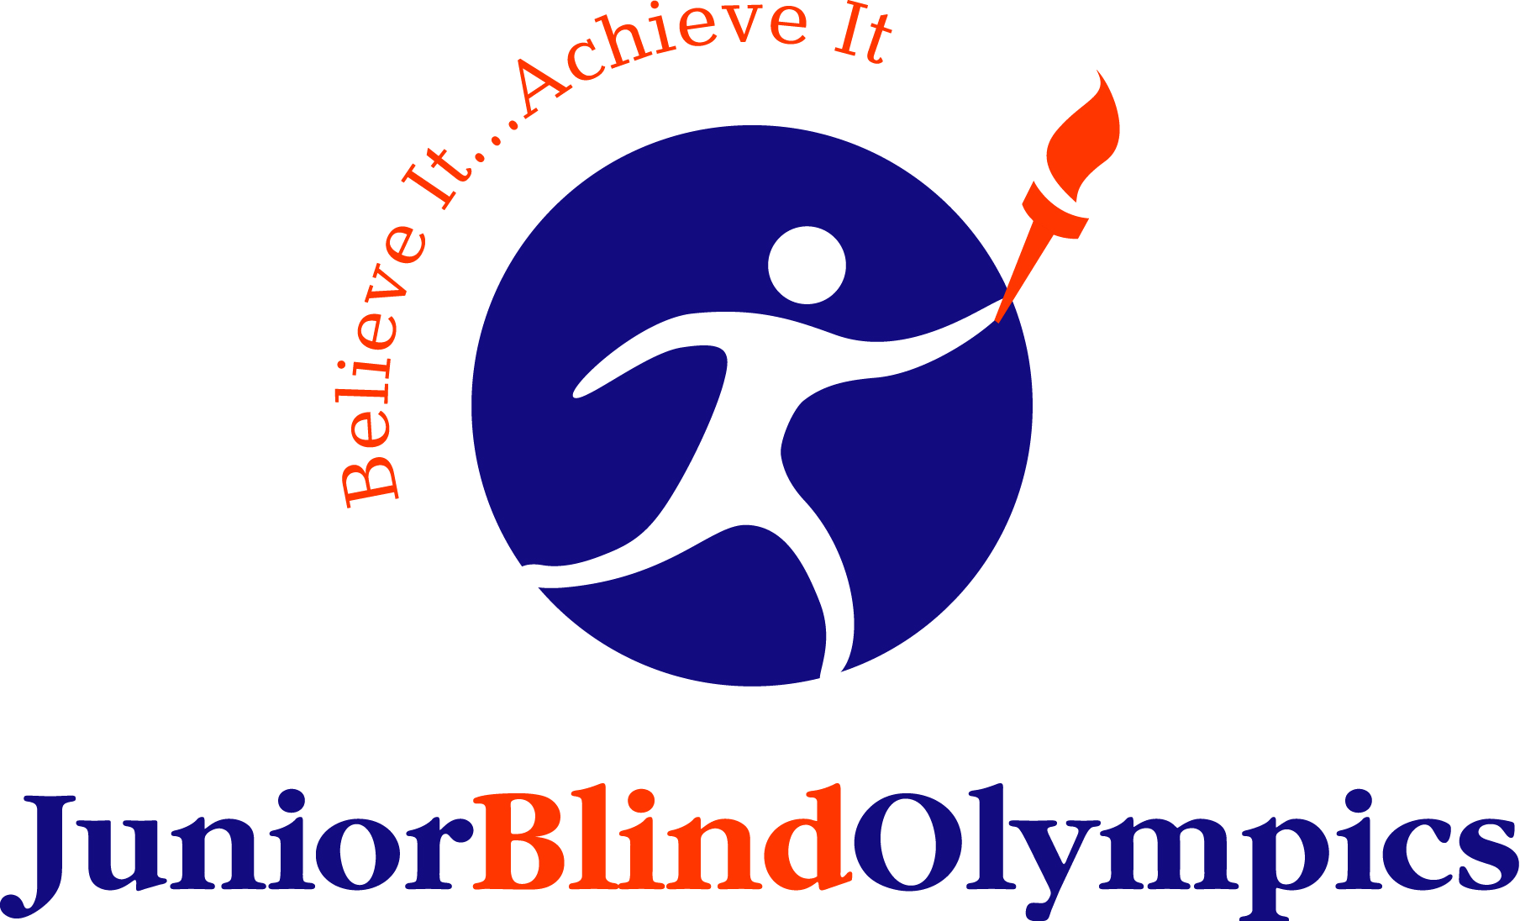

Junior Blind Olympics
Saturday, April 9, 2011
Junior Blind Campus
5300 Angeles Vista Blvd., Los Angeles, CA

UVOLUNTEER REGISTRATION FORM

DEADLINE TO SUBMIT REGISTRATION FORM IS MARCH 11, 2011

Volunteers will be assigned on a first come, first serve basis.
We cannot guarantee your assignment preference, but will do our best to honor your request.

Please complete this form and e-mail it to dmcbeth@juniorblind.org or fax to (323) 295-3021.

For more information, please call Debbie McBeth at (323) 290-6291

Last Name |  |  |  |  |  |  | First Name
Address
 | Street Address City State Zip
Phone |  |  |  |  |  |  | E-Mail
 |  |  |  |  |  |  |  |  |  |  | Confirmations will be sent via e-mail – please write legibly
Employer |  |  |  |  |  |  | Job Title:
Date of Birth |  |  |  | Yes, I’m Under 18 |  |  |  | Name of Group/School/Club:
Minimum Age Requirement is 16-with the possible exception of groups
T-Shirt (Adult) Size: |  | Small |  |  | Medium | Large |  |  | XL |  |  |  | 2XL

VOLUNTEER POSITIONS (Please Select the Area(s) Where You Would Like to Assist)

Competition Volunteer:  Archery, Soccer Throw, Rowing, Rock Climbing, Goalball, Shot Put, Long Jump, 50-Yard Dash. |  |  | Scorekeeper, timer, starter, lane assistant, distance recorder, safety support, etc.  - Select preferred area: Competition (8:00 AM-3:00 PM) Score Keeper (8:00 AM-3:00 PM)  - Preferred competition: Do you have prior experience? Yes No
Coaches:  Must be outgoing, self-motivated, extremely responsible, sociable, able to follow direction and have a lot of energy and patience. |  |  | Athlete escort - encourage participation, stay on schedule, demonstrate leadership, assist in medal ceremony, ensure everyone on the team gets breakfast and lunch, and most important-HAVE FUN.  - Preferred age group to work with: 6-9 10-12 13-15 16-19  - Preferred vision type to work with: Partially Blind Totally Blind  - Do you have previous experience working as a Coach for JBO? Yes No  - Volunteer Hours: 7:00 AM-3:30 PM  We understand there is a long waiting period, but Coaches need to be there early to collect all of the athletes on their teams, and unfortunately not everyone checks in on time–both athletes and volunteers. Waiting period should be used to get to know your athletes to ensure they feel special and have a great time - play games and talk as your role is to be their buddy for the day.
General Volunteer: |  |  | Registration, Food Support, Carnival Games, Arts & Crafts, etc. Please select preferred areas:  Registration (6:00-10:00 AM) Food Support (6:30 AM-2:00 PM) All Others (8:30 AM-3:00 PM)
Pre-Event Volunteer: |  |  | Assist with Goody Bag Assembly, T-Shirts, Prize Sorting, etc.  Please check dates available to assist and write in times available. Hours are anytime between 9:00AM-8:00PM  Days: 04-04-11 04-05-11 04-06-11 04-07-11 04-08-11  Times:
WE WILL CONFIRM YOUR VOLUNTEER RESPONSIBILITY BY MARCH 29TH
(Volunteer positions are limited, so please submit early)

Junior Blind Olympics
Saturday, April 9, 2011
Junior Blind Campus
5300 Angeles Vista Blvd., Los Angeles, CA

UVOLUNTEER REGISTRATION FORM

Authorization for Publicity Consent and General Release
I understand that the information I provide may be verified, and I give permission to Junior Blind of America and Optimist Blind Youth Association to make inquiry of others concerning my suitability to act as a volunteer at the Junior Blind Olympics. I also understand that a personal reference or criminal background check may be accomplished if that action is deemed necessary. In the course of volunteering, I may be dealing with confidential information and I agree to keep said information in the strictest confidence. The relationship between Junior Blind of America, Optimist Blind Youth Association and volunteers may be terminated at any time with or without cause by either the volunteer or Junior Blind of America and Optimist Blind Youth Association.

In consideration for being permitted to volunteer my services, I hereby agree to accept any and all risks of injury (including death), damage or loss of personal property. This is a legally binding liability release, waiver, discharge and covenants not to sue Junior Blind of America, Optimist Blind Youth Association, Los Angeles County Department of Public Health, Smartz Moves, the California Office of Traffic Safety, and any employees or agents representing or related to the Junior Blind Olympics. The undersigned further agrees to abide by the rules and regulations by Junior Blind and/or its affiliate groups and vendors. I represent that I am physically fit and properly conditioned to participate in volunteer activities associated with this event.

Permission is hereby given to Junior Blind of America and Optimist Blind Youth Association to take pictures, motion pictures, video tape or live television pictures, or otherwise record, preserve, reproduce or depict the activities, voice and likeness of the undersigned, and to use any and all of the same publication, including television release and theater viewing, and website or social media site without compensation to said person or to the undersigned on his/her behalf, or individuality.

I have read the Authorization for Publicity Consent & General Release and am in agreement with its content.

Date: Signature:
Parent Signature required for those under age 18.
Parental Consent (Must Be Completed if Volunteer is Under 18 Years of Age)
I hereby consent for my minor child to be a volunteer with Junior Blind of America and Optimist Blind Youth Association. In regard to the above named youth volunteer’s participation, I hereby agree to release and hold harmless Junior Blind of America and Optimist Blind Youth Association, and its agents, employees and representatives of and from any and all liability of any kind or nature incurred by the above-named youth volunteer or by myself as the result of any act or failure to act, intentional or unintentional, by any person who is not an agent, employee or representative of Junior Blind of America and Optimist Blind Youth Association or any other volunteer.

I also authorize Junior Blind of America and Optimist Blind Youth Association, and its agents, employees or representatives into whose care the youth volunteer has been entrusted to consent to any x-ray examination, anesthetic, medial or surgical diagnosis or treatment and hospital supervision and upon the advice of a physician and surgeon licensed under the provisions of the Medical Practice Act or to consent to x-ray examination, anesthetic, dental or surgical diagnosis or treatment and hospital care to be rendered to the youth volunteer by a dentist licensed under the provisions of the Dental Practice Act.

Date: Signature:
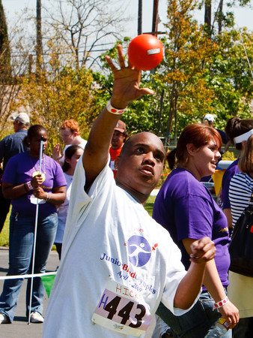
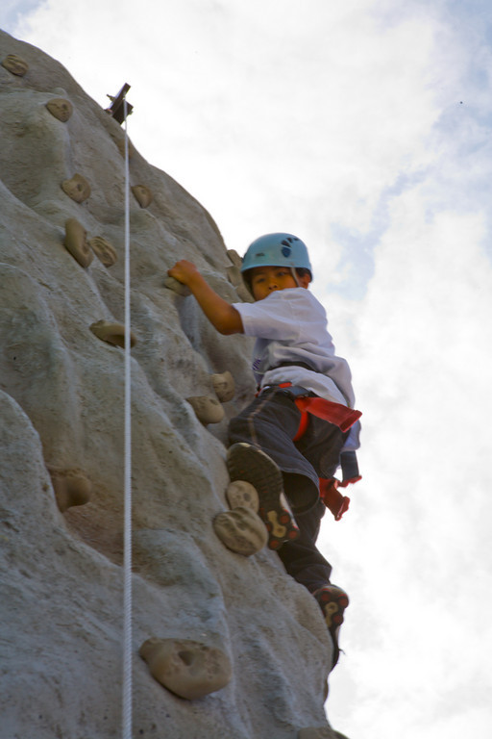
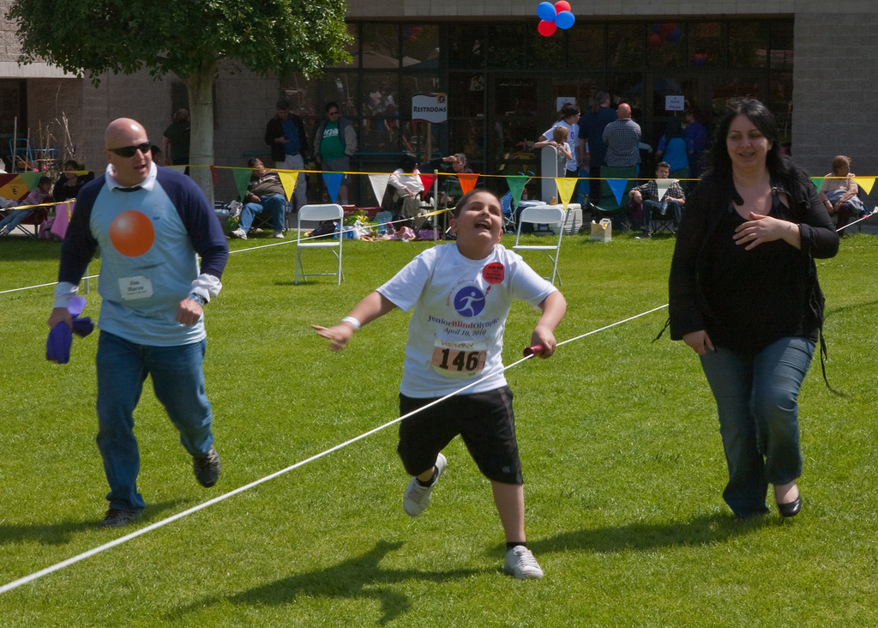
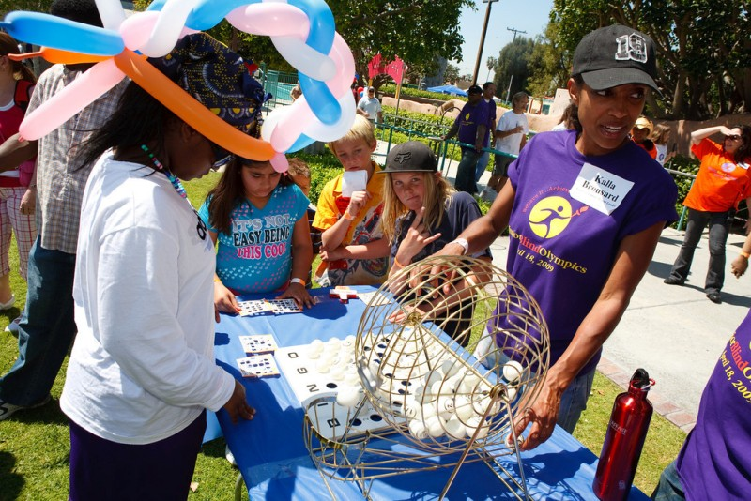
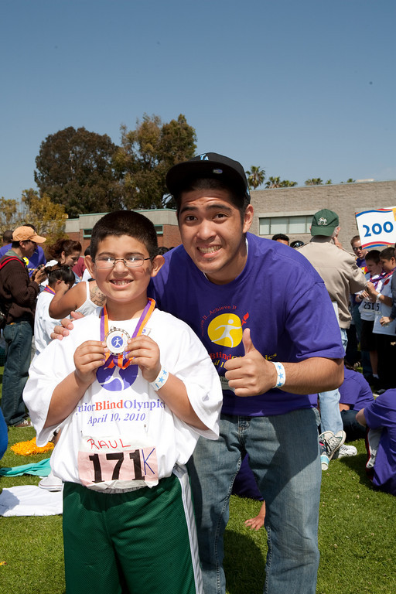
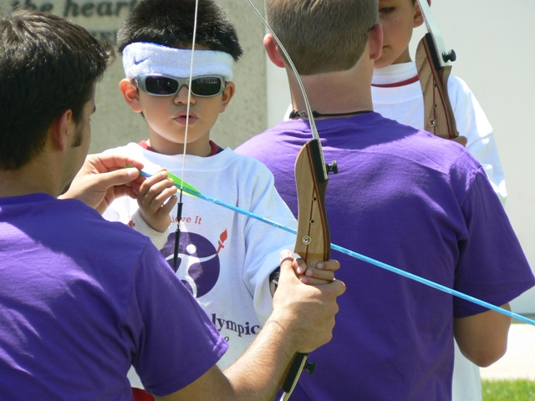
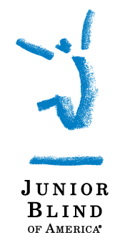
Parent Signature required for those under age 18.

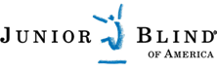
CAMP DAY CELEBRATION
Monday, April 11, 2011

Camp Bloomfield
35375 Mulholland Highway, Malibu 90265

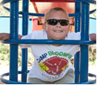
In addition to the Junior Blind Olympics, we also need volunteers to assist
with our Camp Day Celebration at Camp Bloomfield in Malibu on
Monday, April 11, 2011 from 9:00 AM-3:30 PM (Lunch Provided).

Volunteers will assist students who are blind or visually impaired with various outdoor activities such as horseback riding, swimming, hiking, archery, etc.

Last Name |  |  |  | First Name
Address
Street Address City State Zip
Phone |  |  |  | E-Mail
 |  |  |  |  |  |  | Confirmations will be sent via e-mail – please write legibly
Employer: |  |  |  |  | Job Title
Date of Birth |  | Yes, I’m Under 18 | Name of Group/School/Club:
Minimum Age Requirement is 16-with the possible exception of groups

Area(s) of Interest

Please select the area(s) you would like to assist (selecting more than one area is encouraged and we cannot guarantee your selection, although we will do our best to accommodate):

Horseback Riding (9:00 AM-3:30 PM) Arts & Crafts (9:00 AM-12:30 PM)
Archery (9:00 AM-12:30 PM) Swimming (1:30 PM-3:30 PM)
Climbing Wall (9:00 AM-12:30 PM) Tandem Bikes (9:00 AM-3:30 PM)
Hiking (9:00 AM-3:30 PM) No Preference (Wherever Needed)

Liability Release & Publicity Consent
In consideration for being permitted to volunteer my services, I hereby agree to accept any and all risks of injury (including death), damage or loss of personal property occasioned by, or in connection with any activity or accommodations for this event/activity. This is a legally binding liability release, waiver, discharge and covenants not to sue Junior Blind of America, Camp Bloomfield, and any of its employees or agents representing or related to Junior Blind of America or Camp Bloomfield. The undersigned further agrees to abide by all rules and regulations as set forth by Junior Blind of America, Camp Bloomfield, and/or its affiliate groups and vendors. I represent that I am physically fit and properly conditioned to participate in the volunteer activities associated with this event/activity. In the course of volunteering, I may be dealing with confidential information and I agree to keep said information in the strictest confidence.

Permission is hereby given to Junior Blind of America to take pictures, motion pictures, video tape or live television pictures, or otherwise record, preserve, reproduce or depict the activities, voice and likeness of me, and to use any and all of the same publication including television release and theater viewing, and website or social media site without compensation to said person or to the undersigned on his/her behalf, or individuality.

I have read the above Liability Release and Publicity Consent and am in agreement with its content. For those under age 18, parent signature is required.

Date: Signature:
Parent Signature required for those under age 18.

Please Return to Debbie McBeth by March 11, 2011 at dmcbeth@juniorblind.org
or Fax: (323) 295-3021. For more information, please call (323) 290-6291.

